Markham Baptist Church

Markham Ontario

BOARD AND COMMITTEE PROCESSES

2021
UPDATE July 2023`

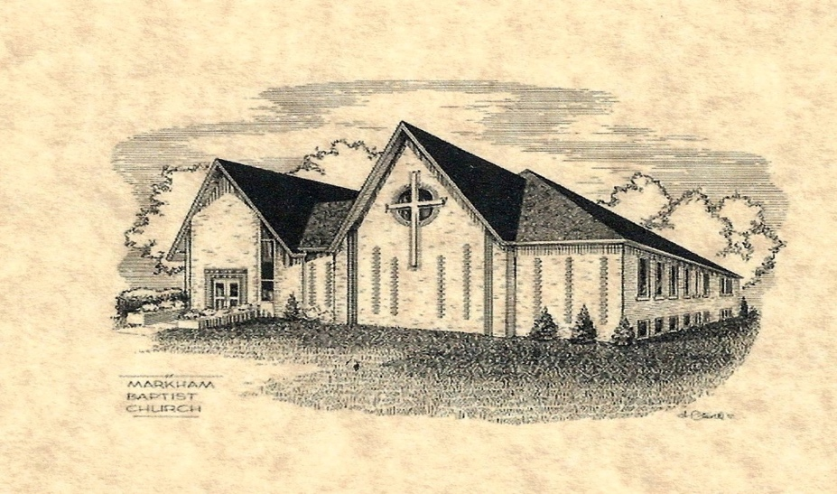

Purpose of the Manual
- To provide consistency in actions and transparency
- To facilitate orientation for new committee members

This manual and all contents are subject to the Markham Baptist Church
General Operating By-Law No 2, September 22, 2014.

The Board of Directors accepted this document for information, February 22 202.,

TRACKING OF UPDATES
Version Number | Revision Date | Summary of Change and page number | Modified by:
1 | Document Accepted by Board February 22, 2021 | Initial Document | Patricia McGee  Marion Waldron
2 | July 2022 | Financial Controls | Patricia McGee  Marion Waldron  Kishan DeSilva
3 | July 2023 | Complete edit | Patricia McGee  Marion Waldron

 | TABLE OF CONTENTS | Page #
 | Cover Page
 | Purpose of Manual
 | Table of Contents | 2-3
SECTION ONE |  | 4
 | MBC Basic Beliefs | 5
 | MBC Core Values and Mission | 6
 | History of Markham Baptist | 7
SECTION TWO | Board of Directors | 10
 | Chair responsibilities | 11
 | Congregational Meetings | 11
 | Policy on Confidentiality | 12
 | Documentation : Confidentiality and Security | 13
 | MBC Plan to Protect index | 14
SECTION THREE | Management Committee | 16
 | Operating Manuals Index | 17
 | Use of Premises Agreement | 18-19
 | Treasurer | 20
 | Comptroller | 20
 | Guidelines for use of funds | 21-22
 | Reimbursement of expenses and form | 23-24
 | Undesignated funds Guidelines | 25-26
 | Payroll process | 27-28
 | Guidelines for Tax receipts | 29-30
 | Securities & Donations Policy and Transfer form | 31-32
 | Bookkeeper | 33
 | Envelop Secretary | 33
 | Tellers | 35-36
 | Church Clerk | 37-38
 | Filing Cabinets | 39
 | Access to Records | 40
 | Records Retention | 41
 | Scent Free | 42
 | MDHS Evacuation Policy/plan | 43
 | TABLE OF CONTENTS. Continued | Page #
SECTION FOUR | Deacons Committee | 44
 | Chair of Deacons’ responsibilities | 45-46
 | Membership | 46
 | Communion | 46
 | Baptism | 47-49
 | Ushers | 48
 | Reimbursement of Expenses | 49-50
 | Watkins fund and forms | 51-53
SECTION FIVE | Christian Education and Outreach Committee | 54
 | Police Checks See MBC P2P Manual | 55
 | Hall. Monitors See MBC P2P Manual | 55
 | Pizza Lunch | 56
 | Sunday School teachers | 57
 | Vacation /Summer Camps | 57-58
 | LOFT | 59
 | Missions Committee | 60-62
SECTION SIX | Nominations Committee | 64
 | Nominations Committee | 65-66
 | Roster of Committees | 67

APPENDICIES | I. Staffing Manual | 68
 | II Funeral Planning | 76
 | III Covid | 80
 | IV Edge Group | 82
 | Suggested Changes | 85

SECTION ONE

Basic Beliefs

Core Values

History of Markham Baptist Church

Notes

The Purpose of this manual is to

- Assist Board/Council chairs and Committee members in carrying out their responsibilities.
as outlined in the By-Laws.
- Provide information that is available and transparent to all members and volunteers.

NOTE forms in this manual are samples.
To obtain a specific form contact the Office Administrator in the office on the main floor.
Markham Baptist Church

Basic Beliefs
- The divine inspiration, inerrancy, and authority of the Bible
- The triune Godhead-Father, Son, and Holy Spirit
- The simultaneous deity and humanity of Jesus, and His virgin birth
- The Person, work, and deity of the Holy Spirit
- The personal existence of God’s defeated enemy, Satan
- The total depravity of man’s nature through the fall
- The bodily resurrection of Jesus
- Salvation by grace alone through faith in Jesus
- Regeneration of believers at conversion by the Holy Spirit
- The baptism of the Holy Spirit at conversion
- The security of every born-again believer
- The sanctification of believers, both in standing (position) and state (practice)
- The giftedness of all believers, by the Holy Spirit- for works of service.
- The unity of believers in the mystical body of Christ
- The imminent return of Christ, personally and bodily to judge the world and
establish His eternal reign/
- The resurrection of the dead

.Our Vision
. With Christ as our model, our vision is to:
- reach out to our community,
- care for individuals and families,
- offer Spirit-filled worship, and use our spiritual gifts.

MBC Core Values
Markham Baptist is a dynamic congregation of people who are passionate about:
- Faith and commitment to Jesus Christ
- God-exalting worship
- Seeking to proclaim God's word because of its ability to transform lives.
- Relying on prayer in all areas of personal and church life
- Excellence in all that we offer to God.
- Learning and living Christ’s teachings
- Modeling Christ’s love for others, through caring relationships
- Evangelism, social concern, and local and international missions

.

Our Mission

Through the Holy Spirit we seek to:
- worship God,
- become fully devoted followers of Jesus Christ, and
- invite others to join us in this life-changing experience.

History of Markham Baptist Church
In November 2015 we celebrated 60 wonderful years as a church family in Markham. Our 60th anniversary celebration was a smashing success, with gala dinner on the Saturday. On Sunday morning our first Pastor Don James was our guest speaker. He and his wife cut our anniversary cake.
During the Covid-19 pandemic, we held an enjoyable Zoom fellowship time to celebrate our 65th Anniversary.
Below is a brief history of our church. Markham Baptist Church started in the early 1950s as an outreach to the village of Markham, which was beginning its transformation from an agriculture community to a commuter destination.
In 1953 a young woman, Miss Pauline Vincent, came to Markham to start the Baptist work. She arranged to stay at a local hotel. But in the early hours of the morning, she was awakened by rowdy celebrations. Fearing for her safety, she knocked on the door of a nearby home. The owner, an Anglican, referred her to a lawyer colleague who was also a Baptist; he and his wife took her in.
Shortly after that, Baptist services were started in the old Orange Hall at the end of Church Street. (It was already called Church Street then; we can’t lay claim to that!) Don James, then a student pastor at McMaster University, came each week and stayed with families to lead services starting in October. Miss Elvira Pepper (later Mrs. Binks) was a driving force behind new work.
The congregation was formally organized as a church on November 13, 1955, with 16 or 17 members One year later we gained official recognition by the Baptist Convention of Ontario and Quebec. They began planning to build a church on the present site which was bought by the Baptist Convention.
In 1957, Paul Burns, another McMaster University student pastor took over leadership of the church. Two years later, the sod was turned in April by Mr. Walter Percy and the cornerstone was laid in November 1959 by Mr. Gordon Ratcliff.
The congregation grew steadily, and in 1988 the membership voted unanimously to expand the church to meet increasing demands.
In June 1990 the sod was turned by Mr. Dean Percy and excavation was started.
In August, Village Baptist Church joined our church family. The new addition was opened in February and dedicated in April 1991. The cornerstone was laid in April by Mr. George Long.
Rev. Dr. Bill Norman was called as pastor and served in that position until 2000 when Rev. Dr. Tom Cullen replaced him.
In recent years, the church has evolved to embrace its culturally diverse community and has developed a strategy focused on addressing the Christian message to the youth of Markham.
Rev. Dr. Tom Cullen served at Markham Baptist until 2009, when Rev. Murray Stovell stepped in as interim Lead pastor while the church searched prayerfully for a new pastor. In April 2011, Rev. Craig Rumble accepted our call and moved his family from Sarnia, Ontario, to become our current Lead pastor.
Our Charter Members
Hilda and Bill Webb, Alvira Pepper, Otha and Don Sim, Joyce and George Long, Wilf Bundy, Hattie Percy, Miss E. Percy, Arlene Rowarth, Sadie and Gordon Ratcliffe, Diane and Ian Ratcliffe, Mrs. Matthews, Don, and Elsie James were MBC charter members.
Our Pastors
Lead Pastors | Youth Leaders
Don James (student) | Ron Hurlburt (1994 – 2004)
Paul Burns (student) | Jamie Eitel (2005 – 2007)
Alf Milligan (first full-time pastor) | Dexter Hinkson (2008 – 2009)
Fred Crossman | Madison Davis 2018 - 2019
Terry Dunlop | Victoria Doran 2019 - 2022
Fred Kahler
Doug Sherwood
Steve Black
Bill Norman (1991 – 2000)
Tom Cullen (2000 – 2009)
Murray Stovell (2009 – 2011)
Craig Rumble (2011 – present)

SECTION TWO

BOARD OF DIRECTORS

Board of Directors

Duties of the Chair

Meetings of the Board/Council
- Notice of Meeting
- Frequency
- Recorder
- Agenda
- Summary of resolutions
- Minutes to be signed by scribe and chair before sending to Church Clerk

Congregational Meetings

- Minimum 3 times per year
- Notice of Meetings
- Agenda preparation
- Recorder
- Summary of resolutions
- Arrangements for slides
- Arrangements for sound
- Arrangements for refreshments

Confidentiality and Security of Documents

Confidentiality
Strict confidentiality required of all individuals involved in a complaint investigation process. A signed confidentiality agreement will be required by all participants involved in the investigation process.

See attached Markham Baptist Church Board and Committee Processes Policy on Confidentiality.
Note – In addition to those named below Board Members are allowed access to all documents through the Church Clerk.
Note – Retention of all documents see Records Retention.

Security of Documents
All records are kept in the Records Room downstairs..

Door Keys to Records Room are held by:
Church Clerk
Treasurer
Office Administrator for maintenance purposes
Filing Administrator re records relating to the MBC P2P Policy

Filing Cabinet Keys in the Records Room are held by:
Blue Filing Cabinet No. 1 (against wall) - Church Clerk and Filing Administrator
Blue Filing Cabinet No. 2 - Church Clerk and Treasurer
3 Drawer Grey Filing Cabinet between the two blue cabinets – Church Clerk and Filing Administrator
This drawer is used for Archived Records of Blue Filing Cabinet No. 1.

NOTE:
Locked Cabinets - Sunday School / Youth Events registration and attendance, Volunteer Records
and P2P Documentation

Non-Locked Cabinets – Management Records, Board and Committee Minutes, CBOQ, General Ledgers, Financial Statements, Bank Statements, Annual Filings etc.

See Blue Cabinets for filing process.

MARKHAM BAPTIST CHURCH PLAN TO PROTECT
A Protection Plan for Children, Youth and Vulnerable Adults

Board Approval on the MAY 1, 2023

All required forms can be found in the MBC P2P. BINDER.
To obtain a specific form contact the Office Administrator
in main floor office.

IMPORTANT NOTE
This policy has been based in part on Plan to Protect® with copyright material from Plan to Protect manual. Permission has been granted to Markham Baptist Church to adapt the material for MBC Church use only. The development and preparation have been undertaken with great care. However, MBC and the employees and agents of Plan to Protect® are not responsible for any errors contained herein or for consequences that may ensue from use of materials or information contained in this work. This is a policy document. This policy is distributed with the understanding that it does not constitute legal advice. This policy is to be available through the member only section of the Markham Baptist Church website.
NOTE:
The full document is in the Records Room and on the MBC website
Contact the Church Clerk fors.

Forms are located in the Administrator’s Office, Main floor.

Posting P2P Certificates
Upon receipt of yearly fees P2P will send a Certificate and Door Sticker.
Adhere sticker to parking lot door.
Make three additional copies to post:
1 in Narthex
1 in downstairs hallway.
1 in large room downstairs
Original Certificate to be sent to MBC P2P Administrators
File all previous year copies in Records Room with P2P Documents

SECTION THREE

MANAGEMENT COMMITTEE

Note: The Management Committee has separate operational manuals /binders kept in the office of the Church Clerk in the Lower Hall (See next page)

OPERATIONS MANUAL INDEX
PLEASE REFER TO MANAGEMENT COMMITTEE MANUALS FOR DETAILED INFORMATION
1 |  | Building Maintenance Schedule
2 |  | Health & Safety Manual - See separate binder
3 |  | Agreements, Roles & Responsibilities
4 |  | Passwords
5 |  | Overhead Projectors and Assisted Listing System
6 |  | Policies, Procedures, Guidelines Index Archived
7 |  | Inside Key Inventory
8 |  | Protector Access Card Log (The Office Manager, Manages & Updates)
9 |  | Fire Safety including Innovative Fire Inc.
10 |  | Church & Group Rentals (the Office Manager updates)
11 |  | Markham District High School - Evacuation Plan
12 |  | Elevator Instructions & Elevating License
13 |  | Combination Lock Instructions - re gate lock
14 |  | Software License for door access keys - next renewal 2021
15 |  | Monthly Automatic Payments
16 |  | Lease Renewals
17 |  | Building Inspection etc.
18 |  | Shredding
19 |  | Backflow Preventer Test & Inspection Report
20 |  | Snow Removal
21 |  | Tree Maintenance
22 |  | Grass Cutting
23 |  | Phone System
24 |  | Photocopier
25 |  | Transfer of Gifts of Securities Form
26 |  | Storm Water Fees
27 |  | Instructions for Digital Sign - Front Lawn
28 |  | Community Mailbox Information
29 |  | Members Section of Website - how to download information
30 |  | Blue Filing Cabinets - Keys - KI Canada
31 |  | T4 Web Code for Filing
32 |  | Canadian Baptists of Ontario and Quebec -Direct Deposit
33 |  | Coffee Maker Instructions
34 |  | Dishwasher Instructions
35 |  | Baptistry Guidelines
36 |  | Expense Reimbursement Form
37 |  | Petty Cash Reimbursement
38 |  | Petty Cash Parameters
39 |  | Payroll Procedure
40 |  | Phone System Setup
41 |  | Pop Machine Information
42 |  | Staff Job Descriptions
43 |  | Pest Control
44 |  | Supplier Insurance Certificates. See separate binder
45 |  | WSIB
46 |  | Undesignated Funds Policy. Building and Equipment Church life and Outreach, CE&O, Memorial
47 |  | Statistics Canada
48 |  | Sunday School Offering Memo 1997
49 |  | Thank you cards to accompany Charitable Receipts
Agreement for Use of Premises

I/We ____________________________________
(name of person or organization)
of address _________________________________________________________
Request the use of (room or facility) ____________________________________
On the following dates and times: ____________________________________

- As a user of the above-described rooms), I/we agree to abide by the following terms, conditions, and responsibilities:
- A fee will be due and payable in advance for the use of the premises.
- Markham Baptist Church reserves the right of use of the building.
- Smoking and use of alcoholic beverages or use of the premises for illegal purposes is not permitted. Public Health Guidelines will be followed.
- User to set up any required chairs and tables and return them to proper storage position after use.
- User to keep the premises in good repair during the permitted occupancy and leave the premises in tidy and clean and good condition, save for normal wear and tear. If the premises are left in an unclean condition for a period of two days after a request from the Management Committee representative to rectify the condition, then the occupied premises may be cleaned, and the cost charged to the user.
- In the event of damage to the premises, the Management Committee representative shall be advised as soon as is reasonable, and arrangements made by the user to repair the premises to the original condition within five days of the sustained damage. If the damage remains unrepaired after five days of written notice to the user by the , the repairs may be affected, and the costs charged to the user.
- User to leave the premises in a locked and secure manner, and lights turned off.
- User is not to cause a nuisance or inconvenience or injury to other groups using the premises, or to any neighbours within reasonable distance from the premises.
- User agrees that any signs, notices, advertisements, or listings of the user which use the name of Markham Baptist Church, shall not be placed without first obtaining the approval of the Management Committee. No sign notice or advertisement by the user shall be placed or posted in the facilities or on the premises without permission of the Management Committee.
- User will not advertise to the public regarding its use of the premises unless approval is obtained from the Management Committee, which approval shall not be unreasonably withheld.
- The Management Committee nor Markham Baptist Church shall not be in any way liable or subject to any action, any claim or demand for damages, loss or injury to the user, its agents or its invitees however arising sustained or occasioned in connection with the permitted use of the premises.
- The Management Committee shall be held harmless and indemnified from all claims, demands or suits made or brought against Markham Baptist Church or the Management Committee arising directly or indirectly out of the permitted use of the premises by the user or its invitees.
- The User will provide a certificate of Liability Insurance.
- The Management Committee agrees to deliver the premises to the user in a reasonably clean and tidy condition upon the time and date stipulated for the proposed use.

- Subject to any fixed period set out above, this use agreement may be terminated by either party on notice of two weeks or without notice should the terms and conditions be violated.
- The person designated on this agreement as the representative for the user will be responsible on behalf of the user for enforcing the above agreements and all other matters relating to the agreement.
- The Board of Management will provide a key to the designated person who will keep it securely and return it at the completion of this agreement.

.
Description of use of premises under this agreement:

Cost of use of premises under this agreement:

Payment arrangements under this agreement:

I/We agree to the above terms and conditions:

Name: ____________________________________

Signed: ____________________________________ Date: ______________

Permission to use the described premises as set out above approved by the Board of Management:

Name: ___________________________________Signed: ____________________________________ Date:

Rental of Facilities

- Arrangements are made with the Office Administrator, in consultation with
a member of the Management Committee or delegate,
- See the attached sample agreement form.
- The Office Administrator keeps a calendar schedule of rentals.
- NOTE MBC is Scent Free
- A copy of the Renters Insurance coverage of the building is required.

Management Committee

Treasurer
- Sit as member of the Management Committee.
- Chair of the Finance Committee.
- Verify approval of all expenses by committee chairs.
- Prepare all payments by cheques or On-Line payments.
- Track and print pre-authorized payments.
- Prepare payroll and confirm with Comptroller.
- Prepare E-Transfer of bi-weekly payroll.
- Submit staff pension contributions to. Canada Life Insurance Company.
- Retrieve Benefit Form sent by J & D Benefits .( Health Insurance)
- Prepare package of receipts and disbursements for the bookkeeper, first week of every month.
- Present Monthly Financial update to Management and Board of Directors
- Present Financial Reports at Congregational meetings .
- Assist with Annual Budget preparation.
- Assist with preparation of information for the Annual Review by Auditor.
- Assist Deacons with financial aspects of salary reviews.
- Follow up on rent and E-Transfers for 114 Church Street property.
- Verify rent from facility rentals.
- Follow up on all lease arrangements.
- Consult with Comptroller to prepare T3010 annual Charitable Report.
- Retrieve and process all donations by e-transfer .
- Prepare summary sheet of all donations received from the Missions Committee
- Prepare requests for payments to Mission recipients and prepares payments .
- Prepare pre-authorized donation list through Scotia Connect (See sample instructions
- Give to Lead Pastor report of yearly transactions for Benevolent Fund.
- Facilitate receipt of security donations.
- Balance and top-up Office Petty Cash as required and December 31.

Comptroller

- Sit as member of the Management and Finance Committees
- Consult on all aspects of financial matters.
- Receive monthly data from Bookkeeper.
- Produce monthly financial statements.
- Confirm payroll with Treasurer.
- Bi-annually prepare and submit GST/PST rebate application .
- Consult with Treasurer to prepare T3010 annual Charitable Report
- Oversee annual budget preparation.
- Confirm information for the Annual Review by Auditor.

- GUIDELINES FOR USE OF FUNDS
Name of Fund | General Fund | Online Ministry | Senior Pastor’s  Sabbatical  Fund
Purpose | Operating Fund for the day to day running of Church activities as per the budge | To support the on-line ministry of MBC | Meet additional costs when Senior Pastor is on Sabbatical
Source of funds | Offerings  Rental income  Interest income Grants/ donations | Special donations | Offerings
Disbursements | CE&O expenses  Congregational Life Expenses  Deacons’ expenses  Management expenses  General expenses  Staff expenses | All Capital and Operating expenses | N/A
Restrictions and Controls | All unbudgeted expenses more than $1000 to be approved by Management Committee  All unbudgeted expenses more than $5000 to be approved by the Board of Directors | Expenses should not be included in the Annual Budget | $500 is accrued in the Deacons’ budget until the fund reaches $5000.  Expenses to be approved by the Deacons’ Committee

GUIDELINES FOR USE OF FUNDS
Name of Fund | Lunch Drop-in | Housing Fund
Purpose | To support Church activities, special projects and donations approved by Lunch drop- in program | To meet housing needs of Pastor
Source of funds | Profits from Lunch drop program. | Donations
Restrictions and Controls | All expenses to be approved by the convenor | Expenses not covered by the Budget

GUIDELINES FOR USE OF FUNDS
Benevolent Fund
To support members and adherents or the congregation and the broader community
in time of need
Offerings and donations
Payment as requested by the Senior Pastor

Confidentiality is vital.

Up to $250 at the discretion of the Pastor
Up to $500 on approval of the Deacons’ Committee
Over $500 on approval of the Board of Directors

When fund drops below $5000. Pastor will alert the congregation that more funds are needed.

Management Committee

Reimbursement of Expenses (Staff and Volunteers)
ALSO LISTED IN DEACONS SECTION AND POLICY AND CARE OF MANAGEMENT AND STAFF

Forms in Office Administrator’s office, Main floor

REIMBURSEMENT OF EXPENSES
Staff members are entitled to reimbursement for documented expenses related to their authorized duties. The reimbursement form is to be signed and submitted to the Church Treasurer. All expenses are subject to the approval of the Chair of Respective Committee.
- Mileage costs will be reimbursed at the CBOQ recommended rates for actual business driving, not including travel between home and the church.
- 407ETR expenses will be reimbursed for business travel that requires the use of this route. A detailed log is the be submitted.
- Meals and other related ministry expenses will be reimbursed when receipts are submitted along with an explanation for the expenses.
- Overnight related ministry events, for staff paid on an hourly basis will be approved by the Chair of the Deacons in consultation with the Lead Pastor. An itinerary will be provided. Registration, accommodation, food, and travel costs will be approved by the Deacons Chair and reimbursed when accompanied by the appropriate receipts. The employee may be paid up to a maximum of 12 hours in a 24-hour overnight situation, at his/her contracted hourly rate of pay. The number of hours submitted may not include hours over the employee’s annual allotment. Reimbursement will not be provided for leisure or sleep hours. The maximum number of ministry related overnight events in a 12-month period may not exceed five (e.g., one professional development event; one each junior and senior CBOQ youth event; one junior/senior youth retreat; and an in-church Thirty Hour Famine).

See sample: Reimbursement Form AND Page 36 of Operations Manual

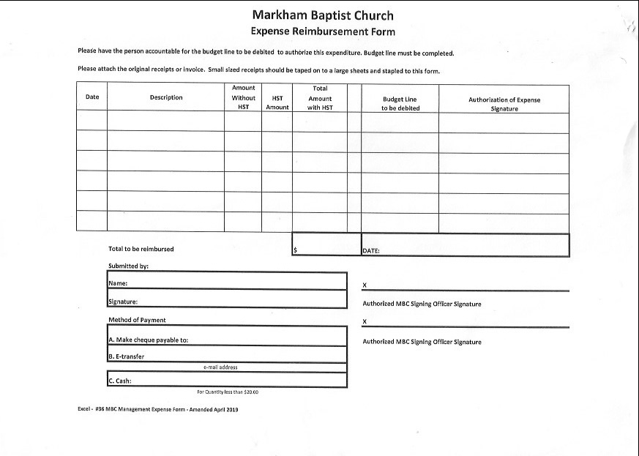
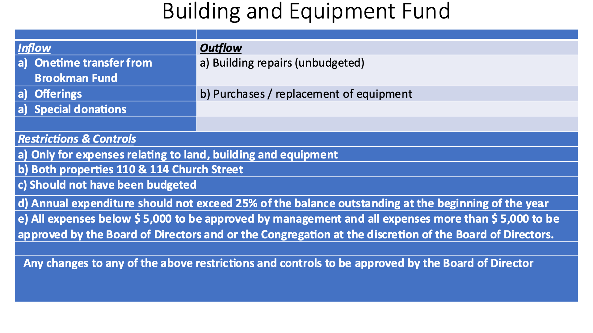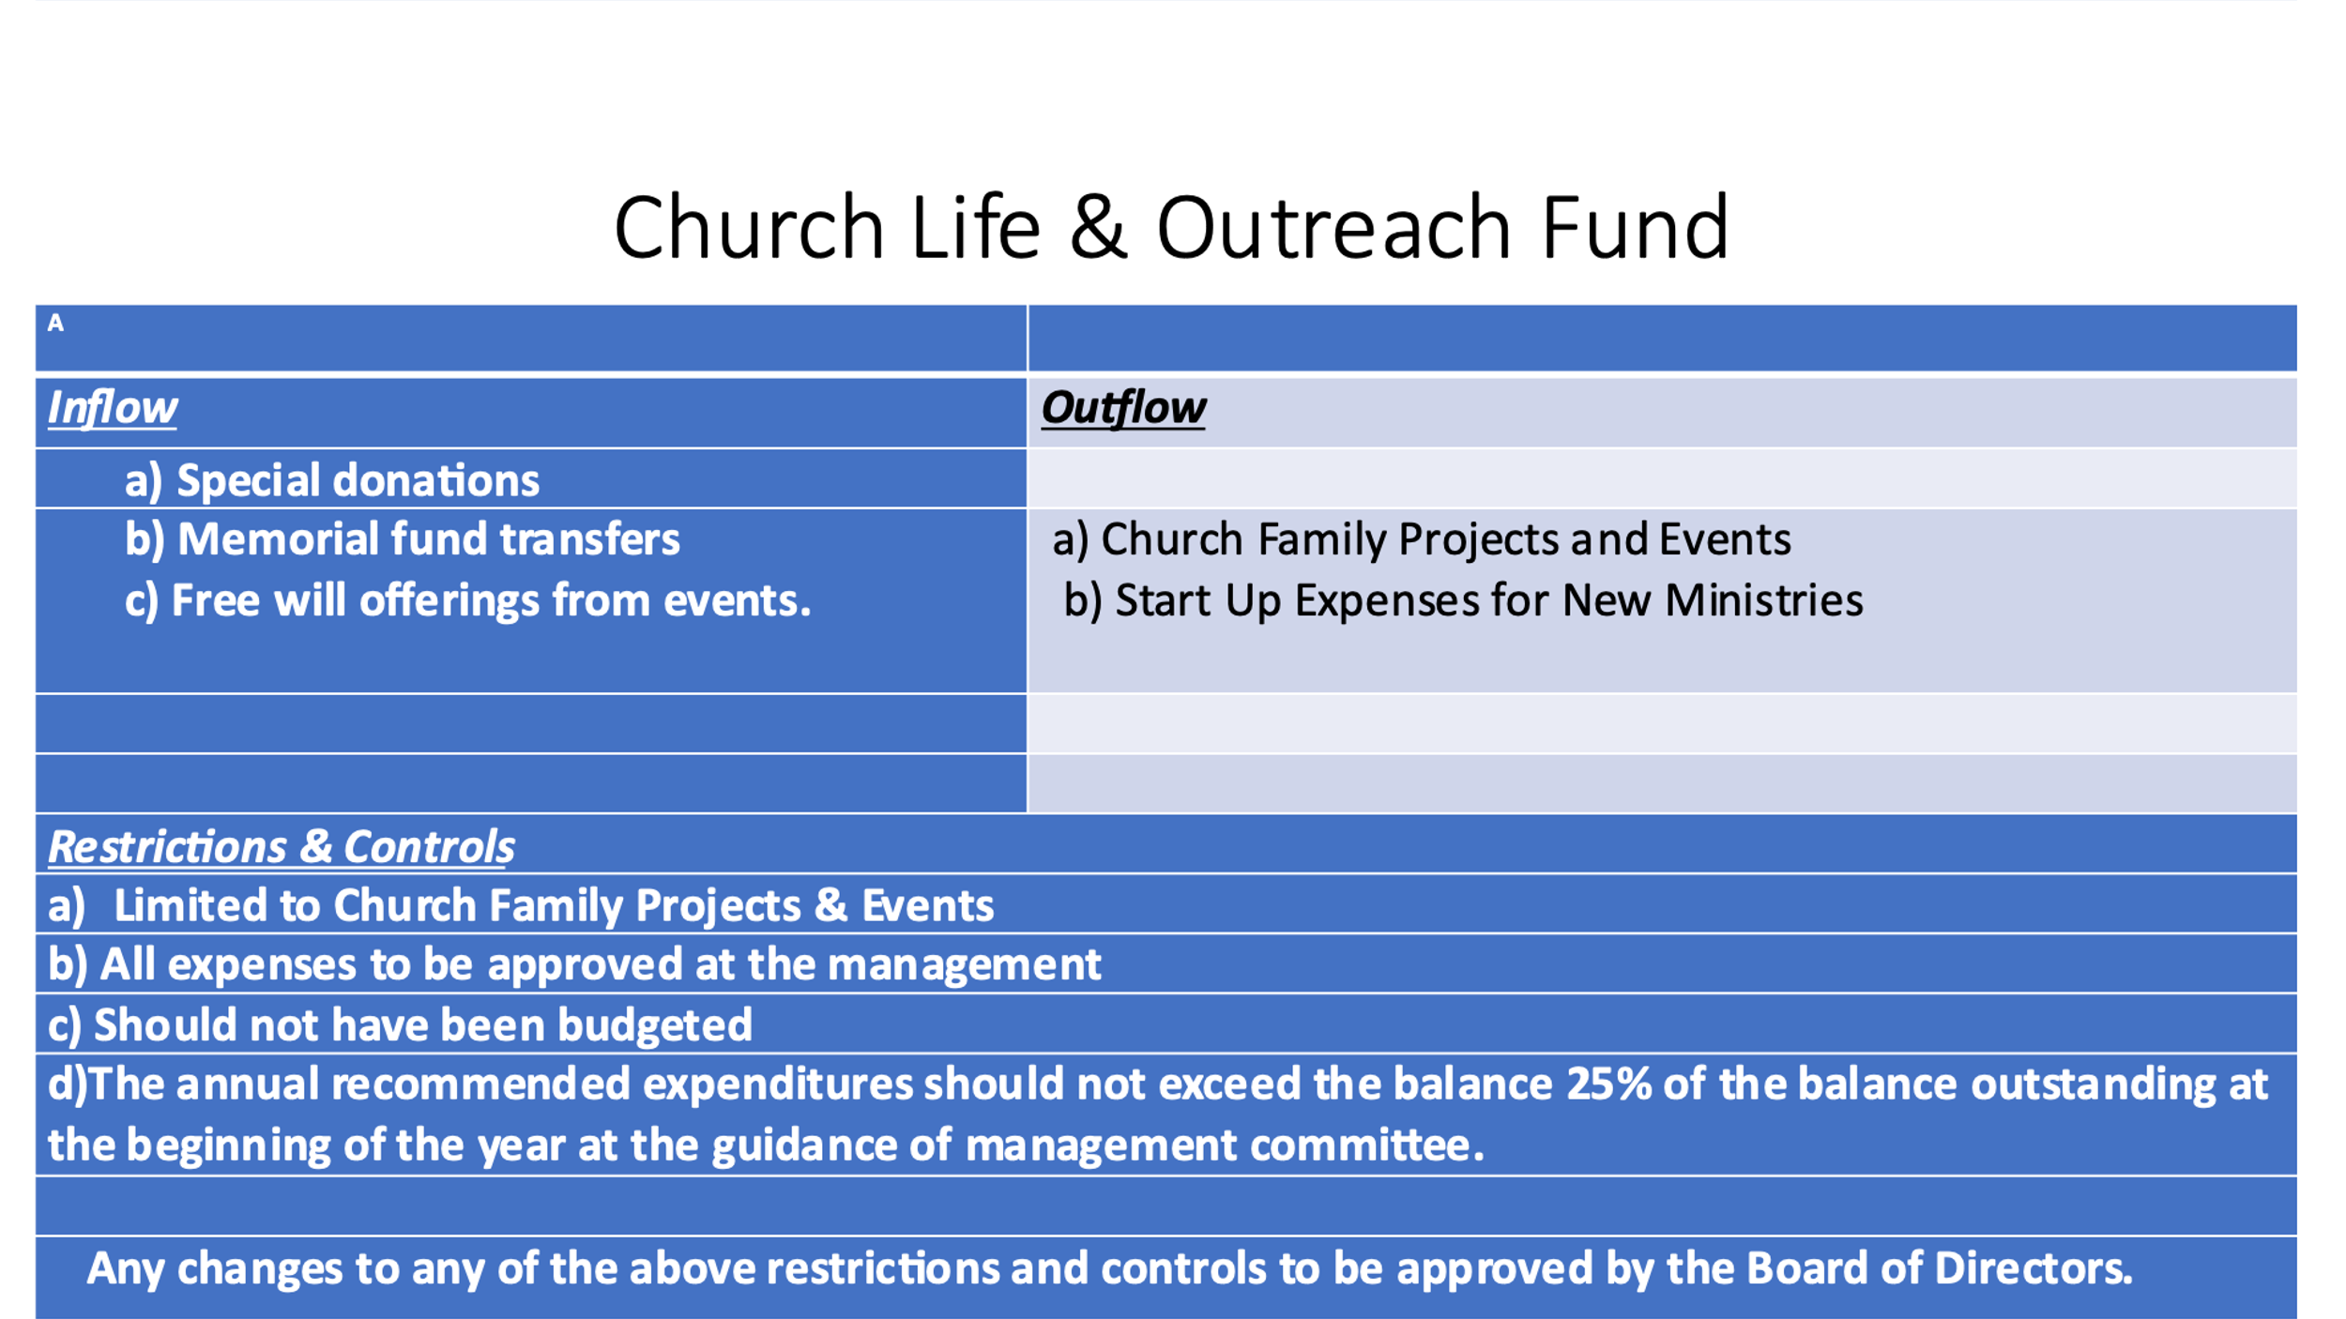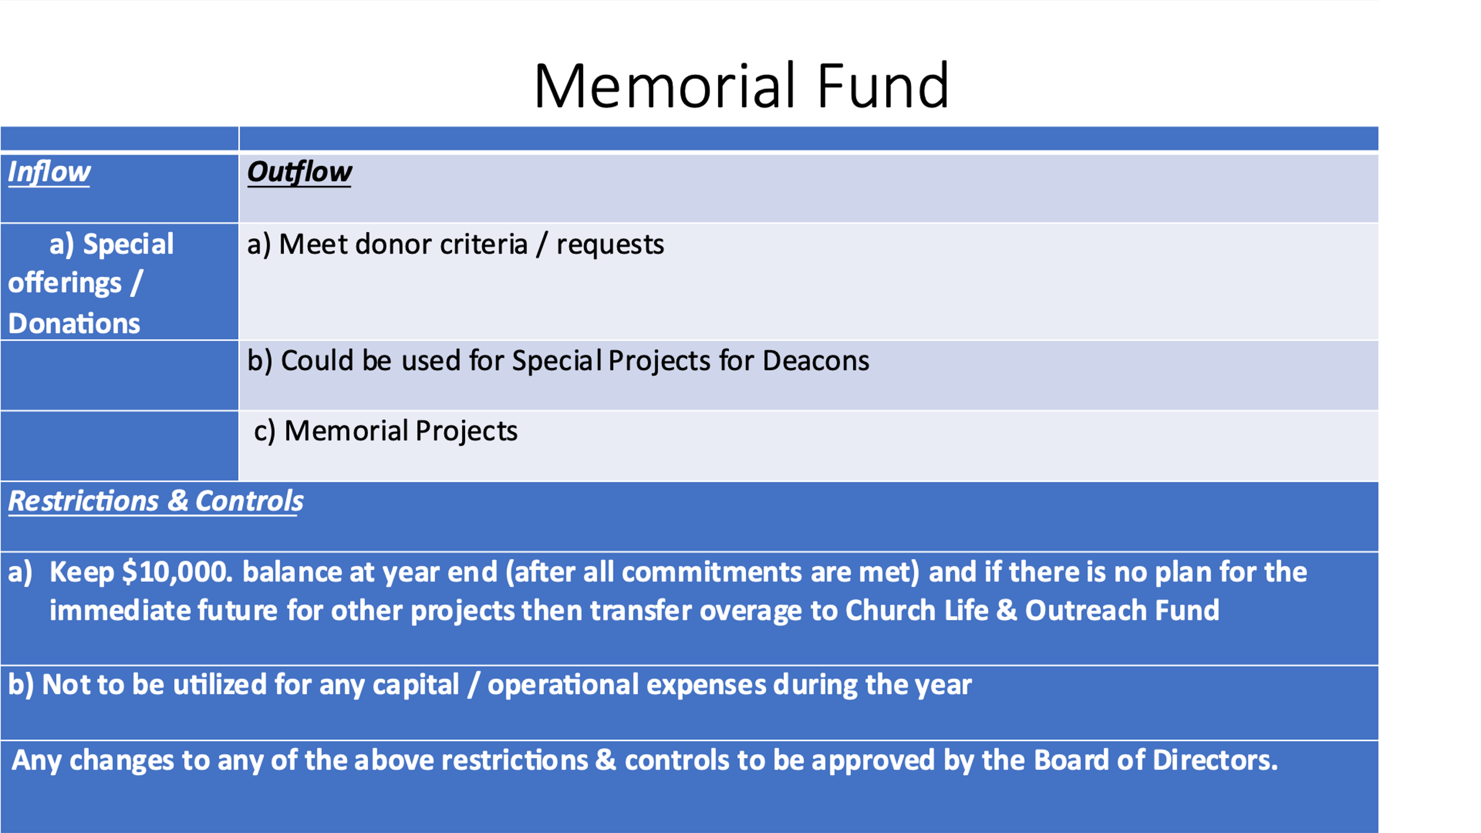

MARKHAM BAPTIST CHURCH
REQUEST FOR UNDESIGNATED FUNDS
UNDESIGNATED FUNDS POLICY MARCH 28th, 2022 (see reverse)
DATE:
 |  | Building and Equipment Fund
 |  | Church Life and Outreach Fund
 |  | Memorial Fund
Description of Request
Amount Requested |  |  | $
Committee Requesting
 |  |  | Chair Approval - Name
 |  |  | Chair Approval - Signature
Management Committee |  |  |  | Name
or Board of Directors Approval
(See Guidelines re |  |  |  | Signature
Restriction levels)
 |  |  |  | Date

Management Committee
Payroll Process.

All part time employees are required to complete the MBC ”Biweekly Time and
Attendance Record.”
form prior to each bi-weekly payroll and submit to Lead Pastor for approval who will then send a copy to the Treasurer and Chair of Deacons – see attached sample.
Treasurer will prepare pay sheets for all employees and send to Comptroller for confirmation.

Treasurer will e-transfer pay to each employee.

Treasurer will give to each employee a copy of his or her pay sheet.

Treasurer will prepare current source deductions for submission to the
Receiver General for Canada before the 15th of the month. Payment via
online bank account –government payments.-

Reference: MBC Operations Manual - #39 Payroll Procedure
Amended September 4, 2020

Markham Baptist Church
Biweekly Time and Attendance Record
Employee Name: |  |  |  |  | Dates |  | Biweekly
Address:
Phone:
Please record hours worked and submit to Lead Pastor for approval.
List Dates Worked | Hours Worked | Activity
 | 0.00
 | 0.00
 | 0.00
 | 0.00
 | 0.00
 | 0.00
 | 0.00
 | 0.00
Total Hrs: | 0.00
Rate/Hour:
Total Pay: | $ -
Signature |  |  |  |  | Date
Lead Pastor Signature
Sick days taken No.____ Dates__________
Vacation days taken No.___ Dates____________
TREASURER COMMENTS :

Management Committee
Guidelines for Issuing Tax Receipts
For a donation to be considered a gift for tax purposes, the following conditions must be met:
- Voluntary and free will donations
- Transferred – from a donor to a registered charity or other qualified doner.
- Property – cash or gifts in kind.
- Types of gifts that generally qualify for Donation Receipts .Cash, Gifts – Cash or Cheques
- Gifts in Kind – Non-Cash Gifts

Gifts in Kind can be:
- Bequests – could be cash.
- Capital Property – stocks, bonds, land, building, equipment etc.
- Personal Property for which fair market value can be determined – computer, clothes,
furniture, artwork etc.
- Life Insurance Policy
- Canadian Cultural Property

Examples of transactions for which no Donation Receipt can be issued:
- Court ordered payment or transfer of property to a charity.
- Payment of basic admission fees
- Payment for a lottery ticket
- Gifts in Kind for which a fair market value cannot be determined.
- Gifts with a direction from the donor to give the funds to a specific person or family.
- Pledges
- Contribution of Services - not property so not eligible

Information we need to know before issuing a receipt:
- What is the fair market value of the property transferred – generally the highest price,
that the property would bring in an open and unrestricted market between a willing buyer
and a willing seller acting independently of each other.

- Has the donor received something in return for the gift –
a charity may choose to give a token of appreciation to the donor in return for the gift,
e.g., property (pen or t shirt), use of property (cottage or vehicle), provision of service
(free day care)?
Fair market value (FMV) of the advantage is the value received by the donor ,
not its cost to the charity.
The eligible amount of the gift may need to be reduced by the amount of the advantage.
If the value of the advantage is the lesser of 10% of the property transferred or $75
it need not be subtracted from the amount of the donation. This rule does not apply to the
value of the activity that is the object of the fund-raising event – e.g., value of dinner,
at dinner fundraiser or golf fees at a golf tournament fundraiser or to cash or near cash
equivalents like gift certificates, coupons, or vouchers.

- Is the gift eligible for a tax receipt? Fair Market Value (FMV) of advantage
received by the donor,
must be 80% or less of the FMV of the donation. Where it is more than 80%
there is no intention to make a gift then no receipt can be issued e.g.,
donor receives a dinner/theatre package worth $175 for a $200 donation is not eligible.

- What is the amount to be receipted?

Property donated for an Auction:
- Receipts can be issued for FMV of the property.
- If FMV cannot be established no receipt should be issued

Bids on items during Auction

- FMV must be established and announced in advance.
- Final bid must meet the intention to give a threshold.
- Charity can calculate the intention to give threshold in advance by
multiplying the FMV by 125%, e.g., FMV is $500 – minimum bid for receipt to be
issued is $625 – highest bid is $750 – tax receipt is $250.
- Golf Tournament Example
- Ticket Price = $300
- Green Fees = $75
- Cart Rental = $25
- Food and beverage = $50
- Door prizes total $3,000 (100 attending therefore $30 each)
- Golf hat = $20
- Door prize + golf hat = $50 which exceeds lesser of $75 or 10% of the $300 ticket price.

Security Donations Policy
Background

Markham Baptist Church has a trading account with TD Waterhouse to be able to accept donations in the form of securities. The signatories on this account are two signing officers and the Treasurer. Any changes to the signatories may be nominated and approved at any Congregational Meeting of Markham Baptist Church.

Any one of the current signatories may execute trades by calling the broker, (online trades are not permitted on this account).

This policy details the process. Markham Baptist Church will follow when a donation in the form of securities is received.

Policy

Typically, the treasurer will be contacted when a security donation is planned to be made to Markham Baptist Church. Whenever this is not the case, whoever is in receipt of the donation form will inform the treasurer immediately.

Normally, the treasurer (or designate) will execute a sale of the securities as soon as possible after the securities are deposited in the Markham Baptist Church trading account.

In rare cases, the donor may recommend that Markham Baptist Church hold the shares for a specified period or there may be market conditions that recommend against immediate sale of certain shares. If for any reason, the treasurer chooses not to execute the sale immediately, this matter will be raised at the first regularly scheduled Management Committee meeting where the reasons for not selling the securities will be discussed and the date of the sale will be set.

When securities are unsold in the trading account, the Management Committee will minute the status of these securities at each subsequent meeting.

Transfer of Gifts or Securities
To Markham Baptist Church
To be completed by the owner of the securities:
Please transfer the following shares to TD Waterhouse Inc. (Dealer #9834; account number 7J2071; branch 79 Wellington Street West, 11th Floor, Toronto, ON M5K 1A1. We have also assigned ownership to the Markham Baptist Church. Upon receipt, the securities will be valued as of the close of trading on the day that they are received and/or sold. A tax receipt will be issued to the donor for this amount.
Name of Donor ______________________________ Daytime telephone: _________________

Address: ____________________________________City/Province: ____________________________

Name of Broker: _______________________________ Broker Firm: _____________________

Broker telephone: ______________________________ Broker Fax: ______________________

Date of Transfer: ______________________________

Full Name and Type of Security ___________________________________________________

Where Traded: ________________________________ Number of Shares _________________

Estimated Value: ______________________________ CUSIP Number: __________________

Description of Shares of Debt instrument (type): ______________________________________

Signature of Donor: _____________________________ Donor Name: ____________________

Please forward this form to the Treasurer, Markham Baptist Church in person or email.

THE PORTION BELOW TO BE COMPLETED BY THE CHURCH:

By this signature I hereby instruct my broker to effect, the transfer to Markham Baptist Church account at TD Waterhouse.

Signature:_________________________ Name: _____________________ Date: ___________

By this signature the sell order is given to TD Waterhouse (John Stewart) Fax 416-983-3866 to be
followed by verbal confirmation prior to the trade.

Management Committee
Bookkeeper

First of the Month:
- Receives package of Receipts, Disbursements etc. from Treasurer
- Enters all information into Quick Book System

Fifteenth of the Month:
- Notify Comptroller when the months entries are completed .
- Prepare and send quarterly reports for each committee chair and discuss as necessary.
- Make all year end entries and put package together for auditor.
- Assist in questionnaire from auditor where necessary.

Management Committee
Envelope Secretary

Process
- Receive weekly teller sheets and e-transfer summary sheets (see attached samples)
- Enter donation amount into receipts program.
- Keep Addresses up to date.
- Print income tax charitable receipts yearly
- Confer with Management for thank you letter to accompany the Charitable receipts.
- Order and distribute offering envelopes.
- Keep Guideline for Issuing Tax Receipts up to date (See Guideline)

Management Committee
Offering process Effective May 15th, 2023
STEP 1
2 people per Sunday
Collect offering from Offering Plate and box at top of stairs.
Record each donation on Summary Sheet - cash and cheques. Total each column and
print name and sign.
Make sure all has been collected from Offering Plate when congregation,,
has left the Sanctuary.
If you find there more envelopes after you have counted put in box at top of stairs
to be counted the following week.
STEP 2
Photocopy cheques and keep with Offering Envelopes.
Prepare deposit slip and take to the bank.
STEP 3
Deposit slip, Offering Cash and Summary Sheet, Envelopes with photocopy of cheques.
to be used to prepare 2 copies of Excel Spreadsheet.

There is a 2nd Excel Spreadsheet prepared for e-transfers received each week.
All e-transfers are deposited directly into the Markham Baptist Church Bank Account.
STEP 4
Use one copy of each Tellers Sheet to enter into Donarius Charitable Receipt
Programme.
Make sure Tellers Sheet and Summary of Donors are in balance in each category i.e.,
General, Missions, Building. Benevolent, Other.
NOTE :
Bank Deposit file consists of:
*Summary of Cash & Cheques with Offering Envelopes, photocopy of cheques
and any other information supplied by Donor.
* Tellers Sheet
*Donor Summary
* Deposit Slip with proof of deposit attached
E-transfer file consists of:
- copy of each E-transfer downloaded from Web Mail
- adding machine tape for total
- Excel Spreadsheet
- Donor Summary
STEP 5
2nd copy of each Tellers Sheet is used by Treasurer to balance to the monthly,
Bank Statement who then gives to Bookkeeper for entering in QuickBooks.

Tellers. (for future reference if needed)

- Office Administrator prepares schedule of Tellers.
- Two tellers per Sunday
- Tellers count offering and prepare Teller Sheet for Envelope Secretary, Treasurer and Bookkeeper
- Tellers prepare deposit slip and place deposit in Drop Box Deposit Bag and
take envelope to the bank drop box using the drop box key.
- Deposit box key in the Tellers drawer in the Church Office
- Return deposit box key to the Tellers drawer before next Sunday.

See Sample Tellers Master Sheet and Tellers e-Transfer sheet.

TELLERS’ SHEET

 |  |  |  |  |  |  |  | Regular offering
Date |  |  | Teller 1
TOTALS |  |  |  |  | (indicates you both verified the envelopes with this sheet)
0.00 |  |  |  |  |  |  |  |  |  |  |  |  |  | Envelope Secretary
BUILDING |  |  | 0.00 |  |  |  |  |  |  |  |  |  |  |  |  |  | Bookkeeper
0.00 |  |  |  | Verify Total
OTHER |  |  | 0.00
 |  |  |  |  |  |  | CASH | 0.00
 |  |  |  |  |  |  | CHEQUES | 0.00
Total Deposit |  |  | 0.00 |  |  |  | Total | 0.00
ENV # |  |  | Total Cheques |  | General |  | Missions | Building |  |  |  | Benevolent |  |  |  | Other | Comments
Loose
 |  |  |  |  |  |  |  | E -TRANSFER
Date |  |  | Teller 1 |  |  |  |  |  |  |  |  | Teller 2
TOTALS |  |  |  |  | (indicates you both verified the envelopes with this sheet)
0.00 |  |  |  |  |  |  |  |  |  |  |  |  |  | Envelope Secretary
MISSIONS |  |  | 0.00 |  |  |  |  |  |  |  |  |  |  |  |  |  | Treasurer
BUILDING |  |  | 0.00 |  |  |  |  |  |  |  |  |  |  |  |  |  | Bookkeeper
0.00 |  |  |  | Verify Total
OTHER |  |  | 0.00
 |  |  |  |  |  |  | CASH | 0.00
 |  |  |  |  |  |  | 0.00
Total Deposit |  |  | 0.00 |  |  |  | Total | 0.00
ENV # |  |  | Total Cheques |  | General |  | Missions | Building |  |  |  | Benevolent |  |  |  | Other | Comments
Loose Money

Management Committee
Church Clerk
Maintains all records of the MBC Corporation
and Designated Person to maintain records of the MBC Plan to Protect program.

Note: All changes to forms and policies are to be sent to the Church Clerk
for updating of Binders and computer backup.

Ongoing
- Continually monitor and update leadership re training and forms
- Keep Members and Adherents Lists up to date.
- Update weddings and memorials to Registry
- Update names of baptismal candidates and baby dedications to Registry
- Prepare hard copy Police Check letters as needed.
- Ensure minutes of all Committees are filed in relevant binders in filing room and
a soft copy in Church clerk files.

January
- Ask for attendance records and prepare numbers for insurance.
- Update Members and Adherents list as of yearend.
- Prepare CBOQ Report. Will receive request by email from CBOQ.
- Prepare copies of Directors' Minutes (Signed) for auditor.
- Prepare Church Clerk report as of December 31^{st..}
- Have Office Administrator to back up office files on MBC external hard drive.
- Collect & file in the yearly binder the Registration, Attendance and Travel Records for
Children and Youth to December 31^{st.}
- Ask Office Administrator for Congregational Attendance for prior year.
- Make new supply of Sunday School Attendance Records

February
- Annual Business Meeting – take minutes – send minutes to the Chair of Board of Directors
and on approval send PDF of Minutes of Congregational Meeting to the Office Administrator
to post on Members section of website.
- Update Members and Adherents List for Deacons.

March April May

Review Membership and Adherent Lists and advise the Chair of Deacons and Pastor
of any changes or motions required – send letters as required for June meeting.

June
- Prepare Church Clerk's report for June Congregational Meeting
- Annual Business Meeting. Take minutes and send to the Moderator.
- When minutes approved send PDF to Office Administrator for posting on web site
- Before June 30 send copy of T3010 Registered Charity Report to CBOQ,
received from Treasurer.
- Ask Treasurer for back up for prior year financial records to be added to MBC hard drive.
- Notify CBOQ of change of officers, volunteers, staff after June Business Meeting
- Prepare Industry Canada Form 4006 Change of Directors within 15 days of June,
Business Meeting

July
- Prepare new Board of Director's lists. Send copy to Scotia Bank
- Collect and file Registration, Attendance and Travel records for children and youth.
August

September
- Replace current Code of Conduct records.
- File previous years records in the middle drawer of the filing cabinet in Records Room
- Print new Sunday School etc. Attendance Records and setup in new year binders by
Filing Administrator
- Review Membership and Adherents Lists and advise Chair of Deacons and Pastor
of any changes or motions required for Fall Business Meeting. Send letters as required.

October or November
- Attend Fall Business Meeting
- Record for Congregational Meetings Minutes and send copy to Moderator.
- When minutes approved send PDF to Office Administrator for posting on web site
- Prepare and send Industry Canada Form 4022 Annual Return.

December
- Update Membership and Adherent Lists. Issue December 31 list of changes
- Start new list for January 1.

FILING CABINETS

Cabinet No. 1
    - Attendance Records
    - Registration Forms
    - Volunteer Records

Cabinet No 2
Drawer 1. Banking, Estates, Personnel
Drawer 2. Payroll
Drawer 3 - Insurance
Drawer 4 - Envelope Secretary
Drawer 5 - Envelope Secretary

Grey Three Drawer Cabinet – PRIOR YEARS RECORDS

Registrations
Travel
Volunteer
Police Checks

Black Two Drawer Cabinet –
Properties 110 and 114 Information
Constitution Information

ACCESS TO RECORDS
NOTE: THIS IS A LIST OF THE FINDERS TO BE FOUND IN THE RECORDS ROOM
All changes to forms, policies etc. to be sent to the Church Clerk
To access the Records Room, contact the Church Clerk who will meet you there.
- Contracts – Purchases
- GST – HST
- Health and Safety Manual
- Management Committee Minutes
- Management Committee Correspondence
- Miscellaneous Correspondence
- Operations Manuals 1, 2, 3,
- MBC Plan to Protect Audit
- MBC Plan to Protect – see Administrator’s Office
- Policy Procedures and Guidelines – ARCHIVED
- Watkins Memorial 2018….
- Watkins Memorial 1992-2018
- Supplier Insurance Certificates
- 60 Years
- 65 Years
- Council / Board of Directors Minutes
- Deacon’s Minutes
- Congregational/Business Meeting Minutes
- CE&O Minutes
- Nominating Reports & Committee Meeting Minutes
- Missions Minutes
- SS Meeting Minutes
- Clerks Records
- Certificate of Continuance
- Annual Programs
- Retreats
- Newcomers, Weddings
- Baby Dedications
- Marriage Register
- Members Correspondence & Baptisms
- Memorial Fund
- In Memory
- CBOQ

Markham Baptist Church – Records Retention as per Canada Revenue Agency

Donation Receipts
Must be kept for 6 years or two years after corporation is dissolved.
10-year gifts – as long as charity is registered and for at
least two years after the charity’s registration is revoked.

Records as follows must be kept for as long as the charity is registered and
for at least two years after the date the corporation is dissolved.
- Minutes of meetings of the directors/trustees/executives
- Minutes of meetings of the members
- Governing documents and by-laws relating to the charity.
General Ledgers, Financial Statements, T3010 Annual Returns, Bank Statements
- Must be kept for six years from the end of the last tax year to which,
they relate, while the charity is registered, and for two years after the date,
the corporation is dissolved.
.
Note Rules for Year End Audit
As a non-soliciting corporation Markham Baptist is only required to have a review not an audit.

BACKUP – quarterly
Office Administrator and Church Clerk to backup files on external
USB drive kept in No. 2 Blue Filing Cabinet – Drawer 1.

Management Committee
Scent Free Policy

MBC strives to be a scent free place. We ask that all those who enter the building be considerate of those who suffer from scent sensitivity or environmental illness. Any or several of the following can result from being exposed to the chemical triggers found in scents.

- Headache
- Dizziness
- Fatigue
- Nausea
- Watery Eyes
- Stuffy nose and or sinusitis
- Coughing
- Chest tightness
- Wheezing
- Shortness of breath

We ask that those entering the building refrain from wearing scented products or switch to scent -free versions of the following products. The list is not exhaustive.

- Perfume
- Cologne
- Aftershave
- Scented hair spray, gels, or other styling products
- Scented face or body creams and lotions
- Scented deodorant

Unscented cleaning products are to be used.

Management Committee

Evacuation Plan for Markham District High School

MDHS Evacuation Plan

Teachers and Educational Assistants with Students by Grade

Grade 9 classes + injured staff and students evacuate to Franklin Public School 21 Franklin Street

Grade 10 classes evacuate to Markham Baptist Church 110 Church Street

Grade 11 and 12 Students (under 18) and their teachers and Educational Assistants evacuate to
Reesor Park Public School 60 Wooten Way North

Teachers take attendance on arrival at the evacuation site.

Teachers and Educational Assistants remain with the class they were with at the
time of the evacuation until instructed otherwise.

White Pass Key to the MBC is in the vault at the High School.
Head of Music Department also has a white Pass key.

SECTION FOUR

DEACONS’ COMMITTEE

Deacons’ Committee
Responsibilities of the Chair of Deacons’ Committee
- Approve expenses (mail slot in Office)
- Appoint a chair and the members of the Watkins Fund Committee
- Arrange Communion server’s schedule .
- Arrange for performance reviews for MBC staff.
- Arrange for personal contacts, visits, cards, and flowers to be sent.
- Arrange for seasonal décor of sanctuary.
- Arrange guest speakers with the Pastor and obtain honorarium cheques,
from the Treasurer.
- Arrange prayer opportunities .
- Arrange preparation of elements for Communion
- Arrange for ushers and coordinator of ushers and orientation for ushers.
- Attend as many Sunday services and church events as possible.
- Attend meetings of Board of Directors/Council
- Care for MBC family members, adherents
- Care for the Pastor and staff and deacons
- Co-ordinate funeral receptions when required.
- Communicate and co-ordinate with other committees .
- Coordinate Baptisms and education for candidates with the Pastor
- Coordinate fellowship events
- Delegate to committee members where possible
- Inform the Hearts and Flowers committee of need for cards or flowers.
- Keep Deacons apprised and updated as appropriate..
- Manage Watkins Memorial Fund
- Meet with Pastor on a regular basis.
- Orient new deacons in the serving of Communion
- Plan Pastor’s vacation schedule.
- Prepare monthly report for Board of Directors /Council meetings.
- Prepare Personnel and General Budget in November /December and
discuss with Treasurer.
- Provide information for updating of employment contracts as needed.
- Record dates of guest speakers
- Sign and send minutes of meetings to the Church Clerk.
- Spend time in prayer, Practise Spiritual Disciplines.
- Support small groups /study groups and service focused groups.
- Support updating of Church Directory as needed.
- Update Members and Adherents List as needed with the Church Clerk
- Welcome guests and visitors to the church.
- Schedule Committee meetings
- Prepare Agendas for meetings with input from Pastor.
- Ensure that minutes of meetings are circulated to Deacons.
- When minutes are approved and signed , forward to the Church Clerk.

Deacons’ Committee
Membership (see By-Law SECTION 11)

- With the Pastor arrange to provide introduction and orientation classes for those
seeking baptism and or membership
- Book the class location.
- Arrange for a member of the Deacons’ Committee to attend.
- Arrange for a personal interview with each person, couple, or family with two Deacons.
- Participate in the service when the new member is welcome.
- Present the names of the perspective new members to the congregation for a
motion of acceptance and vote.

Note
Baptism candidates are welcomed to the church membership following their Baptism.
A special meeting of the congregation may be convened to vote on the membership.

Deacons’ Committee
Communion

- Arrange dates of monthly Communion services including additional times such as
Good Friday or Christmas Eve with officiating Pastor
- Arrange a schedule of servers at a Deacons’ meeting.
- Orient servers when new Deacons join the committee.
- Arrange a team of people to set up and clean Communion trays and the
empty cups in the pews.

Deacons’ Committee. Baptisms
Guidelines for Deacons
*Confirm date of Baptism with Pastor and Candidates
*Arrange to have enough Baptismal gowns available for the service and arrange for cleaning afterwards.
*Arrange with Management Committee for the baptismal tank to be cleaned and filled with warm water,
*Arrange for a person to assist each candidate before and after the baptism.
*Arrange for a person to mop dry the Pastor’s washroom, stairs ladies and men’s
lower-level washrooms.
*Provide large plastic bags for the wet baptismal gowns.
*Connect with the candidates afterwards.
* Arrange with Moderator for congregation to approve the acceptance into
Membership if the candidate wishes.
*Welcome the candidates into membership at the following Sunday if possible.

Guidelines for Baptismal Candidates
Things to have with you :
- Swimsuit to wear under Baptismal gown.
- A white collared shirt or blouse to wear under the gown.
- Sandals or thongs because floor may be wet when you exit the baptismal tank.
- Two bath towels
- Facecloth
- Hair dryer as needed to dry your hair.
- Hairbrush / comb
- Kleenex
- Plastic bag for wet towels and clothes
- Your testimony, written out/typed for reading it while in the Baptismal tank.
Include:
What Jesus means to you.
The Scripture verse that is important to you
Why this is an important step in your spiritual journey .
How this will affect your life going forward
- Arrive by 10 AM
- Pick up your gown from the coat rack outside the Pastor’s office or in the lower hall.
- Change in lower- level washroom.
- By 10:15 meet in the gym with the person assigned to assist you and any
other candidates and for last minute instructions and prayer with the Pastor
- Wet gowns to be left in the lower-level kitchen after Baptism so they can be taken to
Cleaners.
- It is advisable for the chair to not be on the schedule list so they can be available,
to serve in case the scheduled deacon is unable to attend.
- Chair should come prepared at each Communion date to pray or serve,
in case a scheduled deacon cannot be present.
Deacons’ Committee
Instructions for Ushers
- Be at the doors at least 15 minutes before the service starts.
- Leave doors closed until 10 minutes before start of service if the musicians are practicing.
- Prior to the service, check the pews to ensure all old bulletins, papers and garbage have been removed.
- Pencils and offering envelopes should be in the racks.
- Encourage regular attendees who arrive early to move forward to allow late comers and new people a row at the back.
- Shape newcomers’ first impressions of us. Offer a welcoming hand and introduce yourself.
- If possible, ask newcomer for name and pass on to the Pastor or a Deacon after the service.
- If the sanctuary is getting full, look for empty spaces, and encourage those already seated to move together.
- Close the sanctuary doors as the service starts and only allow late comers in at appropriate breaks.
- Provide fresh bottle of water for speakers.
- For the offering, you will need 4 people and use only 3 offering plates to avoid confusion. If younger children are helping you, please make sure that they know ahead of time what is expected.
- Start at the front and progress to the back. If needed, ask someone in advance of the service to help with this.
- Sit at the back of the sanctuary during the service and be ready to assist anyone who needs help coming in or out.
- Parents of children age, 4 and 5 need to sign them in for Sunday School. Remember to give the book to the leader before the children go downstairs.
- Count the number of people present before the children leave for Sunday School and record number on the sheet provided.
- At the end of the service open the sanctuary doors, pick up and recycle Bulletins and other papers left behind.
- On Communion Sundays, please remove and recycle communion cups.
- If you are unable to meet your obligation on a given Sunday, please try and switch with another ushering team member.

Duplicate of Management Section for information

Reimbursement of Expenses
Forms in Office Administrators office

REIMBURSEMENT OF EXPENSES

Staff members are entitled to reimbursement for documented expenses related to their
Authorized duties. The reimbursement form is to be signed and submitted to the
Church Treasurer.

All expenses are subject to the approval of the Chair of the Deacons’ Committee.
- Mileage costs will be reimbursed at the CBOQ recommended rates for actual business ,
driving, not including travel between home and the church.
- 407ETR expenses will be reimbursed for business travel that requires the use of this route.
A detailed log is the be submitted.
- Meals and other related ministry expenses will be reimbursed when expenditure receipts
are submitted along with an explanation for the expenses.
- Overnight related ministry events, for staff paid on an hourly basis will be approved by the Chair of the Deacons in consultation with the Lead Pastor. An itinerary will be provided. Registration, accommodation, food, and travel costs will be approved by the Deacons Chair and reimbursed when accompanied by the appropriate receipts. The employee may be paid up to a maximum of 12 hours in a 24-hour overnight situation, at his/her contracted hourly rate of pay. The number of hours submitted may not include hours over the employee’s annual allotment. Reimbursement will not be provided for leisure or sleep hours. The maximum number of ministry related overnight events in a 12-month period may not exceed five (e.g., one professional development event; one each junior and senior CBOQ youth event; one junior/senior youth retreat; and an in-church Thirty Hour Famine).

See sample: Reimbursement Form in the Management section or in the Management,
Manual of Operations

Deacons’ Committee
The Watkins Memorial Fund October 16, 2000, Version 2
Mission Statement
DEACONS’ COMMITTEE
THE WATKINS FUND MEMORIAL FUND
Mission Statement for Watkins Fund
This fund is intended to encourage and provide financial assistance to youth of Markham Baptist Church and missionaries supported by Markham Baptist Church in their Christian endeavors. Itis not intended as a sole source or for long term support.

Watkins Memorial Fund
Len Watkins and his wife were members of Markham Baptist Church from 1962 until
Their deaths. The principal money of the fund was bequeathed by Mr. Watkins to MBC and is held in trust by the Baptist Convention of Ontario and Quebec.

Objectives
Consistent with the vision of Markham Baptist Church which is "to know Him and to make Him known", the following objectives guide awards made from the fund. The Watkins Fund is to provide financial assistance to:
1) youth of MBC while attending post-secondary schools of Christian Education
2) youth of MBC, who if assistance is not given, could not attend summer camps
3) youth of MBC who attend Christian camps as counsellors or who participate in mission
field trips. Awards are intended to be used to replace money that would have been earned at a summer job and be used toward post-secondary education. Requests that meet these criteria will be given priority over other similar requests,
4) Missionaries who are supported by MBC as they serve in foreign or home situations.

Amount of Awards
- The maximum award should not exceed $500.00 or 50% of the total cost of the project.
- Amounts may also be limited by the size of the fund and the number of requests received.
- Money will only be provided when there is money available and there is a financial need.
- An individual may receive up to a maximum of $1500 during any 5-year period.
- If there is money remaining at the end of a year, requests above this maximum will be.
considered.

Process
The following process will be used.
1) Requester to fill out the form on the front page of this package and submit to either the
Pastor, a member of the Board of Deacons, or a member of the Watkins Memorial Fund
Committee.
2) The Watkins Fund Committee will review all submissions and accept those meeting the
fund guidelines. The Deacons will review requests, the Watkins Fund Committee recommendations, awards and the status of the fund on an annual basis. Each submitter may be asked to meet with the committee as part of this review.3) Each person awarded money may be asked to present to an appropriate Church group on the experience gained as a result of the award.

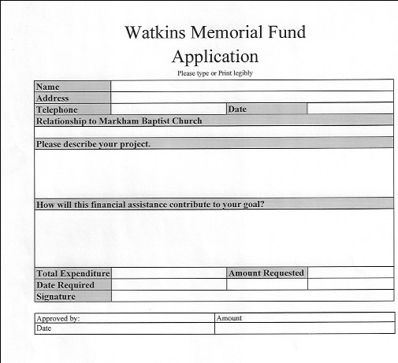

Name of Fund | Watkins Fund
Purpose | To support student participation in mission opportunities
Source of funds | Interest income from the Trust held by CBOQ
Disbursements | Expenses related to student missions
Restrictions and Controls | Amount of Awards  - The maximum award should not exceed $500.00 or 50% of the total cost of the project.  - Amounts may also be limited by the size of the fund and the number of requests received.  - Money will only be provided when there is money available and there is a financial need.  - An individual may receive up to a maximum of $1500 during any 5-year period.  - If there is money remaining at the end of a year, requests above this maximum will be considered.  Award to be approved by the Deacons Committee  See the Watkins Memorial Fund policy for further information

SECTION FIVE

CHRISTIAN EDUCATION AND
OUTREACH COMMTTEE

MISSIONS COMMITTEE

Christian Education and Outreach Committee
Police Checks
See MBC Plan to Protect (MBC P2P) for directions.
- Police Checks are required for all leaders..
- Forms: in Office Administrator’s office
- Supervision of Children, Vulnerable adults, and Youth on retreats.
- CE&O committee to arrange for supervision for children and vulnerable adults,
during all youth activities services and ministry opportunities.
- Examples include but not limited to. Avalanche, Blizzard, 30 Hour Famine,
Camping experiences on or offsite

Christian Education and Outreach Committee
Hall monitors duties
See MBC Plan to Protect (MBC P2P) for directions.
- Attend MBC P2P policy training annually.
- Available 9AM to 11AM on Sundays
- Do at least one run through the entire church building including storage rooms,
on Sunday at a randomly selected time during Junior and Senior high classes.
- Collect the offering from both groups and drop them off in an envelope to the
Treasurers mail slot.
- Ensure the Primary school Register is in the church foyer before the
Sunday Service and Nursery Register is in the Nursery.
- Do one run through the entire church at a random time during the church service .
- Collect Sunday school and nursery offerings and drop them off in an envelope.
to the Treasurers mail slot in the main floor office.
- Assist with younger children who need bathroom breaks based on
MBC P2P Policy
- Not required to be available on weekends of Statutory holidays or
- during school breaks

Christian Education and Outreach Committee
Pizza Lunch
- See MBC Plan to Protect for directions.
- Volunteers require Plan to protect training annually.
- Volunteers should know the location of First Aid box and Ice packs.
- Volunteers should acquaint themselves with Fire Safety plans and
evacuation routes.
- One person should be the lead on safety measures .
- Volunteers should review first aid training . http://first aid
certification.org/free course
- 10:30am to 1:15 pm Wednesday during school term
- Set up church hall for serving pizza lunch, set out games and.
Table Tennis table.
- order pizzas in advance on Tuesday according to historic numbers separately for
first lunch break
- Greet Markham District High Youth at the church door and count number of
students attending lunch drop in.
- Supervise basketball court.
- Order pizza for second lunch break based on how much is consumed at the
first break.
- At end of 2nd lunch break, count money and complete banking and
administrative forms. (Note: this should be done by 2 MBC Volunteers
away from general view)
- Conduct periodic hall monitoring by adult volunteers during first and
second lunch.
- All activities need to be staffed by adult volunteers in accordance with
MBC P2P policy.
- Return pizza bags and pay pizza provider.
- Bank cash

Christian Education and Outreach Committee
Sunday School Teachers
See MBC Plan to Protect (MBC P2P)
- Require Plan to protect training annually.
- Parents are to register their children each week.
- Follow classroom staffing guidelines.
- Prepare Sunday School lesson from curriculum prior to Sunday School lesson.
- Assist in selecting curriculum for the school year.
- Junior and Senior high Sunday School Sunday mornings
- Sunday school starts immediately following children’s story and prayer in
sanctuary every Sundays in school year.
- Hall monitors and Sunday School teachers are needed from first Sunday after the
Labour Day weekend in September until Schools close in June.
- Sunday School Teachers and Hall monitors are not required to be available on
weekends of Statutory holidays or during school breaks.

Children’s’ Vacation Camps
GUIDELINES FOR CHILDREN’S CAMP FUND

The purpose of the Children’s Camp Fund is to help children attend summer camp,
who would otherwise be unable to due to financial difficulties.

The Fund will be a offered only to those children who wish to attend a Christian camp ,
approved by the CE&O committee, such as Muskoka Woods or Camp Kwasind.
the funds will now help children to go to other Christian Camps.

The maximum amount requested and awarded should not exceed $500 per year,
per child and no more than the total cost of camp registration.

The family making a request should pay whatever amount they are comfortable with.

The amount awarded may also be limited by the size of the Fund and the number of
requests received. Money will only be provided when there is money available.

An application must be completed and submitted to a member of the CE&O
Committee for approval. The CE&O committee will notify the Treasurer of their
decision and request payment.

CHILDREN’S CAMP FUND APPLICATION FORM

Childs Information
Full Name
Date of Birth
Address
Parent/Guardian information
Email Address
Relationship to child
Address if different from child
NOTE
Health/ immunization information will be required by the camp
Camp Information
Date of Camp Session
Cost of Camp Session
Amount of. Money being requested
Camp Website

Name of Fund | Children’s Camp Fund
Purpose | To give children and opportunity to attend Christian Camps
Source of funds | Donations, Sales, Profit from Fund Raisers, or events
Disbursements | Camp Fees
Restrictions and Controls | Approval of CE&O  Maximum awarded should not exceed $500. per year per child.  And is no more that the total cost of camp registration.  The annual amount awarded should not exceed 25% of the fund.

LOFT. aka MBC YOUTH GROUP

Guideline for Loft Allowable Spending of Budgeted Funds
- Youth Retreats and Events – Leaders and Travel Expenses
- Movie Nights and Outings – Leaders’ expenses when required to comply with
- MBC Plan to Protect guidelines. For example, two or more drivers.
- Start of Season Kick-off – food, entrance gift
- End of Season BBQ food, graduation gifts, etc.
- Volunteer Lunches
- Loft Apparel
- Christmas Party
- Weekly Events – material
- Office Supplies, Resources

Christian Education and Outreach Committee
Missions Subcommittee
MISSION TEAM
The MBC mission team is a subcommittee of CE&O
Purpose of the Mission Policy
- to further the mission vision of Markham Baptist Church
- to raise awareness of needs, physical and spiritual, both locally and globally
- to assist people to invite others to be reconciled to God and to further enlist and enable.
people in using their spiritual gifts.
Mission Policy Statement
Annually, Markham Baptist Church will develop a mission focus in support of MBC.
local and global mission partners and agencies.
Congregants will be encouraged to participate in short-term and long-term missions both.
within Canada and Internationally.

Definition of Terms
- Missions: Opportunities to minister to the whole need of people in our own community
and in the worldwide community. We believe that salvation and faith transcend,
geographic, and ethnic borders.

- Short-term mission: Intercultural projects or service opportunities that provide aid,
or assistance to sponsored agencies.

- Intercultural: The mission focus can be within one’s own community or
country or in another
geographic location.

Christian Education and Outreach Committee

Scriptural Basis for Mission
We, the people of Markham Baptist Church, believe that Jesus Christ speaks directly to us in Matthew 28:19-20:
“Go and make disciples of all nations, baptizing them in the name of the Father and of the Son and of the Holy Spirit, and teaching them to obey everything I have commanded you.”
Matthew 9:36-38 gives an example of mission showing Christ’s compassion for the lost:
“When He saw the crowds, He had compassion for them, because they were harassed and helpless, like sheep without a shepherd. Then He said to his disciples, ‘The harvest is plentiful, but the laborers are few: therefore, ask the Lord of the harvest to send out labourers into His harvest.”
The MBC mission team will:

- Encourage the MBC congregation to further develop interest and skills in reaching out to others.
- Enable MBC outreach cross-culturally at home and abroad.
- Seek opportunities that further the mission and vision of MBC.
- Assure volunteers that they are prayerfully encouraged and supported.
- Fund missions through the annual Missions budget
  - Develop and manage the Missions budget annually.
  - Contribution is limited to the sized of the fund.
  - If there is money remaining at the end of the year, it may be used in the following year.

- Encourage the congregation to support individuals who are actively involved in missions.
- Promote the exploration of long-term missionary assignments within the congregation of MBC.
- Invite speakers from our mission partners and agencies, arranging hospitality and honorariums for them.
- Communicate and promote mission plans to CE&O and the congregation.
- Evaluate mission events regularly.
- Review the Mission Policy annually.

Note: From time to time the Congregation may raise special funds for special one-time mission projects as approved by the Board of Directors.

Name of Fund | Missions Fund
Purpose | To support Missions, Charities and special giving undertaken by the Church
Source of funds | Offerings and special donations
Disbursements | Donations to Charities and Missions
Restrictions and Controls | Develop and manage the Missions budget annually.  Contribution is limited to the size of the fund.  If there is money  remaining at the end of the year, it may be used in the following year.

SECTION SIX

NOMINATING COMMITTEE

NOMINATING COMMITTEE

This Policy and Procedure is to outline the duties and responsibilities of the Nominating Committee, the Terms of Office for all positions, as outlined in the Constitution and/or By-laws and to provide the methodology for filling those positions.

The Nominating Committee has four (4) main responsibilities:
Put forward a slate of officers and names for positions as outlined in the Constitution ,
and By-laws for voting upon by the Church Membership at the Annual Congregational Meeting.

- Meeting. (AGM)
- Put forward names for positions as vacancies arise, to be voted upon by the Membership at any Church Congregational Meeting.
- Maintaining records of all positions as outlined in the Constitution and By-laws. These records shall include the position name, individual in the position, start of term, end of term and length of time in position.
- Act as an inventory of skills and resources to all Committees.

Process:
Most positions will be filled at the AGM based on the Report of the Nominating Committee presented. The Nominating Committee will first obtain the agreement of each individual prior to putting forth his or her name for a vote by the Church Membership. Nomination will only be accepted from the floor at a Congregational Meeting after prior consultation with the Nominating Committee and upon prior agreement with the individual to be nominated. If for any reason all vacant positions as outlined in the Constitution or the By-Laws are not filled, the Church shall continue to function and will not be considered in violation of the Constitution. The Nominating Committee will continue to endeavor to fill all vacant positions.

Vacant positions will be filled on an “As Needed Basis”. Positions that become vacant between Annual Program Meetings may be filled as part of any Congregational Meeting of the Church. It is the Nominating Committee’s responsibility in consultation with the other Committee Chairs to find suitable individuals for each position. Nominations will only be accepted from the floor at a Business Meeting after prior consultation with the Nominating Committee and upon prior agreement with the individual to be nominated.

Terms of Positions:

The following are the recommended positions as outlined in the Constitution and By-Laws that are required to be nominated. If for any reason at the Program Annual Meeting, Nominating Committee is unable to present a full slate to fill all vacancies, Nominating Committee will continue its search for suitable individuals to fill each position and the Church will continue to operate in compliance with the Constitution.

It is intended that each position will be elected to serve for a term as outlined below, provided that there are no mid-term resignations or previous vacancies. Should vacancies occur mid-term the position may be filled for the remainder of the term.

For the Committees of Deacons, Christian Education and Outreach, Management and Nominating these are the minimum recommended number of positions. If additional member(s) are required, they may be added under the same rules and terms as other members.
Standard Term is two years. An individual may serve a maximum of 6 years in any one position and/or as Member of a Committee without taking at least one year off from that position or committee.

If due to a resignation or any other reason, a position of less than a full term will also be filled on an “as needed” basis following normal Nominating procedures.

Notes: It is the intention of Nominating Committee under ideal circumstances, for the purposes of consistency and historical knowledge retention, that the following term expiry should be maintained:
- Moderator and Church Clerk positions should be on terms that
expire on alternative years.
- Chairs of Management and the Treasurer should be on terms
that expire on alternative years.
- Chairs of Deacon, Management, Christian Education and
Nominating should be on terms such that only two expire per year.

Other Duties or Responsibilities
Nominating Committee should maintain a “Skills Inventory” of individuals, both Church Members and other regular attendees. This Inventory will be used to match individual skills to positions. It will also serve as way for individuals to express an interest in various areas of service.

Nominating roster

Position | # Positions | 2 Year Term
Moderator | 1 Church Member | 1 elected every 2 years
Church Clerk | 1 Church Member | 1 elected every 2 years
Treasurer | 1 Church Member | 1 elected every 2 years
Elected Directors | 2 Church Members | 1 elected every year
Deacons | 6 Church Members | 3 elected 1st year  3 elected 2nd year
Christian Education and Outreach | 4 of which 3 are  Church Members | 2 elected 1st year  2 elected 2nd year
Management | 4 of which 3 are Church.  Members +Treasurer | 2 elected 1st year  2 elected 2nd year
Nominating | 3 Church Members | 2 elected 1st year  1 elected 2nd year

APPENDIX I
Deacons’ Committee
Staffing Manual

Policy for the Care and Management of Staff Members

Prepared by

Deacons Committee

Approved by Board of Directors

April 13, 2015

Replaces Previous version – Staff Policy

Dated March 6, 2003

Updated September 9, 2019

The Deacons Committee is accountable to the congregation for the employment and care of MBC staff members. This policy guideline is subject to the Employment Standards Act of Ontario, the MBC By-Laws, the Leadership Policy, and any contract negotiated with a staff member and approved by the congregation.

PURPOSE
The purpose of the policy is to:
Promote fairness and transparency in the care and management of full-time and
part-time staff members and those in contracted positions,
Guide in the recruitment, employment ,and orientation of new staff members
Reflect the Core Values of MBC. Appendix 1

DEFINITION OF TERMS
A Staff Member refers to all pastoral, worship, youth ministry leader and administrative staff and anyone who from time to time is employed in a contracted position.

Employee refers to a person who provides service to the church in exchange for wages. The employer/employee relationship is defined in the Employment Standards Act (2000)
Lead Pastor refers to the person who is responsible for the spiritual development of the congregation and provides Biblical leadership to all ministry areas .

Pastoral staff refers to the person who is responsible for the spiritual development of the congregation and provides Biblical leadership to a specific area of ministry.

Youth Ministry Leader refers to the person who is responsible for youth ministries .

Office Administrative staff member refers to the person responsible for the day-to-day office duties.

Full-time employee/ full-time staff refers to a person who works 37-1/2 hours per week or more and is paid a salary and is entitled to benefits.

Part-time employee or part-time staff refers to a person who works fewer than 37-1/2 hours per week or is paid on an hourly basis.

Contract employee/contract staff refers to a person who works for a defined period as outlined in a contractual agreement.

ACCOUNTABILITY
Pastoral, Youth Ministry Leader, and Office Administrative staff members are accountable to the congregation/appropriate group(s) through the Deacons’ Committee Chair. On a day-to-day basis staff members report to and are accountable to the Lead Pastor.

Staff members are encouraged to be accountable to a person or group of persons outside the congregation for spiritual, physical, and family health.

CODE OF CONDUCT
Staff members are expected to follow the lifestyle “Guidelines of Conduct Policy for Employees of Markham Baptist Church” (See Plan to Protect)

All staff members who interact with vulnerable people will adhere to the requirements of the MBC Leadership Policy – Plan to Protect – September 10, 2018.

JOB DESCRIPTIONS

There are current Job Descriptions for the following positions:
- Lead Pastor
- Youth Ministry Leader
- Office Administrator

Job descriptions will be reviewed every two years to ensure that they reflect the current vision and plans of MBC.

PERFORMANCE REVIEW

The purpose of the annual performance review is:
- To encourage and assist the staff member.
  - In his/her ministry
  - In his/her own self-evaluation
  - In the development of his/her abilities and skills.
- To engage the congregation in its own review of the staff member’s progress
and development.

The review is to be carried out annually by the Chair of the Deacons’ Committee

or their delegate.

The process includes:
- Shared goal setting at the beginning of the program year in discussion with the
Lead Pastor and the Chair of the Deacons’ Committee or delegate.
- Regular and immediate feedback is encouraged during the program year.
- Written self-assessment and written review and discussion with the staff members,
at the end of the program year.

COMPENSATION AND BENEFITS

Compensation and Benefits will reflect CBOQ guidelines.

- Salaries at MBC will strive to have consistent pay practices that are fair to the employee, that recognize the significant ministries of the staff member and that allow us to attract and retain high caliber staff to support the vision and mission of MBC.
- Annual adjustment to salaries will be recommended by the Deacons’ Committee in consultation with the Management committee and recommended for consideration and approval to the annual Financial Business meeting of the corporation.
- Clergy residence is not provided. The clergy residence deduction for income tax purposes will adhere to CRA guidelines. Required documentation to apply for this deduction will be provided by the Church Treasurer.
- Benefits
  - Benefits are available for full-time and part–time staff members who are paid for 20 hours per week or more.
  - CPP and EI: The church is required by law to pay its share of Canada Pension Plan and Employment Insurance
  - Pension Plan payments comply with the CBOQ Pension plan. The church pays 6.00% of employment earning. An additional 6.00% is withheld from the staff member’s salary and remitted to the CBOQ pension offices on his/her behalf. This is a CRA requirement.

- Group Insurance: Group Life, Health, Disability Long Term Disability Insurance and Employee Assistance Plan benefits are provided for all MBC employees working 20 hours or more per week and is available through the CBOQ group plan.
Should a staff member decline any group benefits, a signed waiver is to be retained by the church.

EQUIPMENT AND SPACE ALLOCATION
The Lead Pastor, the Youth Ministry Leader and the Office Administrator will be provided with appropriate workspaces, equipped with telephones, Wi-Fi, internet, email access and compatible mobile computing devices. Software updates will be provided on a regular basis.

REIMBURSEMENT OF EXPENSES
Staff members are entitled to reimbursement for documented expenses related to their authorized duties. The reimbursement form is to be signed and submitted to the Church Treasurer. All expenses are subject to the approval of the Chair of the Deacons’ Committee.
- Mileage costs will be reimbursed at the CBOQ recommended rates for actual business driving, not including travel between home and the church.
- 407ETR expenses will be reimbursed for business travel that requires the use of this route. A detailed log is the be submitted.
- Meals and other related ministry expenses will be reimbursed when receipts are submitted along with an explanation for the expenses.
- Overnight related ministry events, for staff paid on an hourly basis will be approved by the Chair of the Deacons in consultation with the Lead Pastor. An itinerary will be provided. Registration, accommodation, food, and travel costs will be approved by the Deacons Chair and reimbursed when accompanied by the appropriate receipts. The employee may be paid up to a maximum of 12 hours in a 24-hour overnight situation, at his/her contracted hourly rate of pay. The number of hours submitted may not include hours over the employee’s annual allotment. Reimbursement will not be provided for leisure or sleep hours. The maximum number of ministry related overnight events in a 12-month period may not exceed five one professional development event; one each junior and senior CBOQ youth event; one junior/senior youth retreat; and an in-church Thirty Hour Famine

VACATION AND TIME OFF
Vacation pays as per the Employment Standards Act (2000):
4% of earnings for 1st five years, 6% 5 to 10 years, 8% over 10 years.

Time off without pay may be negotiated with the Lead Pastor and approved by
the Chair of the Deacons’ Committee.

Statutory Holidays:
The following statutory holidays will be observed each year:
New Year’s Day
Family Day
Good Friday
Easter Monday
Victoria Day
Canada Day
Civic Holiday
Labor Day
Thanksgiving Day
Christmas Day
Boxing Day
If a statutory holiday falls on a Saturday, Sunday or on a scheduled day off, a day
in lieu will be scheduled.

For part-time staff statutory holiday entitlement will be pro-rated based on the
number of hours worked in the previous 4 weeks divided by 20.

4. Maternal and Paternal Leave will be granted in accordance with provincial legislation.

5. Bereavement Leave
In addition to care and support, Markham Baptist Church will extend basic pay privileges,
for all employees who have suffered a death in their immediate family. Immediate family
is defined as mother, father, brother, sister, spouse, child, brother or sister-in-law, mother,
or father-in-law, or grandparent.

The following time off will be granted (or additional time as may be appropriate)
with the approval of the Chair of the Deacons’ Committee:
  - Employee’s spouse or child – up to five scheduled working days
  - Other immediate family – up to three scheduled working days
  - In other instances (aunt, uncle, cousin) – up to one scheduled working day to attend the
funeral.

Staff member may be asked to supply a copy of the death certificate.

This policy does not apply if the death occurs during an employee’s vacation.

6. Sick Leave:
[As per CBOQ] Each full-time employee shall receive credit for 15 days paid sick leave per year, accumulated at 1.25 days per month.

Unused sick leave credit will be allowed to accumulate from year to year to a maximum of 85 days, for use only in the case of illness. In the event of extended disability absence, and where accumulated sick leave and vacation credits have run out, an employee may be paid at a rate of 75% of his/her regular salary up to the end of 17 weeks absence, at which time Long-Term Disability Insurance benefits come into effect. Accumulated sick leave will not be reimbursed for cash under any circumstances and is forfeited at termination.

Each part-time employee shall receive credit for paid sick leave on a pro-rated basis that is proportional to the time he or she works.

7. Jury Duty:
Employees who are summoned to serve on jury duty will receive regular pay (minus any court stipend) for each day they are required to attend or serve the court. The employee must provide a signed document from the clerk of the court, stating the time in attendance and the amount of payment received from the court.

PROFESSIONAL DEVELOPMENT

Continuing Education:
All staff are encouraged to remain current, through reading and/or by attending conferences and seminars as appropriate throughout the year. Continuing education activities are to be included as part of the annual staff evaluation discussion and approval is required from the Deacons’ Committee.
A period of up to 10 days will be set aside annually for continuing education for pastoral staff. One such study leave should be taken in any two-year period. Additional time may be granted in exceptional circumstances. Approval is required from the Deacons Committee.

An amount will be provided each year in the budget for Continuing Education and book allowance. Amounts not spent in a given fiscal year may be accumulated with the approval of the Deacons’ Committee.
Pastoral Day Apart:
All pastoral staff are encouraged to take one day apart in each six-week period for prayer, reflection, and personal spiritual refreshment.

Guest Speaking Engagements
The Pastor(s) may wish to take advantage of guest speaking invitations from time to time.
Such requests shall be submitted to the Deacons Committee for approval. Such requests from the pastoral staff must be submitted first to the Lead Pastor.

Sabbatical Leave

Sabbatical leave is provided only for the full time Lead Pastor
Long-term pastorates are key to a strong missional church. A sabbatical leave enriches the
church and the pastor.
- By encouraging the retention of the Lead Pastor
- By avoiding spiritual burnout and emotional exhaustion in the Lead Pastor
that can often result in illness and require time off.
- By avoiding the cost and disruption of recruiting, replacing, and orienting a
new staff member.

The purposes of the sabbatical leave may include opportunity and time:
- To renew or refocus the pastor’s vision and mission.
- For observation and experience in other areas of ministry or mission .
- For quietness and refreshment of physical and spiritual health .
- For research or writing related to the profession..
- For further study to refine and update professional skills

The concept of Sabbatical is rooted in scripture. Following the model of Sabbath rest after the 6th day, a sabbatical may be requested for a period of three to six months after each six years of ministry at MBC. The length of the sabbatical will not exceed six months and may be divided for example one-half after the fifth year and one-half after the seventh year.

The sabbatical should be planned one year in advance. The Lead Pastor will provide the Deacons’ Committee with a proposal that will be a broad outline of the purposes and objectives for the leave. Brief interim reports during the leave will be provided to the Deacons’ Committee on an agreed upon schedule.

The Lead Pastor will receive full pay and benefits from the church during the
Sabbatical unless otherwise funded.

The Lead Pastor is expected to remain on staff for at least 2 years following the
sabbatical leave.
The Lead Pastor will assist the Deacons’ Committee in arranging interim staffing so
that there is continuity of ministry.

RESIGNATION
Should an employee choose to resign, written notice must be provided to the Chair of the
Deacons Committee. The resignation must be accepted by vote of the congregation.
Negotiation of exit procedures will take place with the Deacons’ Committee.

CONFLICT RESOLUTION
It is our desire to create a climate of open discussion, understanding and mutual respect for every member of the body.
- Any complaint or concern of staff should be shared with the Lead Pastor for resolution.
- If resolution with the Lead Pastor is not possible, the matter may be referred to the
- Chair of the Deacons’ Committee and the Deacon responsible for administration
of the policy who will seek a resolution.
- All reasonable steps will be taken to find a resolution. The steps may include,
consultation with the Church Moderator, or a mutually acceptable person
designated by CBOQ.

Matthew 18: 15-17 provides guidance for the resolution of disputes.

SEXUAL HARASSMENT and DISCRIMINATION

MBC is committed to providing a work environment that recognizes the dignity and
worth of every person and is free of harassment and discrimination.
[The Ontario Human Rights Code] MBC practises Zero tolerance environment.

.

APPENDIX II

Funeral Planning

Questions to ask the family ahead of time, by the pastor, Office Administrator
or a Deacon
- How many people expected to attend?
- How many immediate family members to reserve seating.
for at front of sanctuary?
- Any video / slide show to be projected prior / during service?
- Soloists / musicians that need microphones?
- Does family wish the service to be videotaped?
- Will the casket be brought into church? (if yes, will need to arrange with
- Management to remove doorpost at entry.)
- Any display of photos in lobby/downstairs during reception?
(need to arrange for easel sand/or display tables)
- Church staff to prepare program/bulletin to hand out to guests.
- Do they wish to have a reception to follow?
- How would they like it to be arranged ? Budget?
- If Luncheon is to be held , see additional Luncheon Reception questions below.

For large funerals
- HAVE 1 OR 2 PEOPLE available in parking lot to direct traffic.
- direct people to park in straight lines across the parking lot rather,
than on an angle, so we can fit approximately 20 more cars .
- Once the lot is full, direct people to either park on the street or at MDHS.

- Greeters : One at the Parking lot entrance and One at street entrance doors
to direct people to go through the gym and enter the sanctuary through the
lobby so that users can assist with seating.

Ushers 2 – 3 ushers needed.
- Reserve seats in front pews for family
- Make sure LOTS of boxes of tissues are placed on front pews .
- If a lot of people are expected, usher people right to seats and encourage,
them to "squish in" as far as comfortable .
- If more than 175 people are expected, consider including seating in the library,
with video feed .
- Can also provide another video feed in the lobby - if still more, overflow,
people can stand in lobby to watch – People cannot sit in the lobby.
because of fire regulations

Audiovisual/ Sound
- 1 person, if just audio requirements
- 2nd person if slides and/or video to be shown.
- Possibly 3rd person to videotape service for family.
- If doing a video feed to library and/or lobby, need another person as "standby,"
just in case there is some glitch with the video feed and need to troubleshoot.

Other:
- Ask Management Committee to arrange cleaning of church (Sanctuary, Lobby,
- Lower hall, washrooms) morning of service, if possible.

Luncheon Reception
Questions to ask:
How long will the service be?
Will there be an interment following the service? If yes, how much time to allow,
in between service and reception?
Will a luncheon be provided? (sandwiches, veggies, and cookies,
OR Squares, and cookies only?)
Budget?
Arrange for food delivery at least one hour before funeral start time.
How many people expected?
Consider known food allergies?
General:
- As soon as possible, ask Office Administrator to send group e-mail for:
  - help to set up.
  - help to serve.
  - help to cleanup.
  - Where possible, assign people to various tasks:
Set Up: Depending on numbers expected.
- 2 long food tables in front of kitchen (2 long white tablecloths)
- 5 round tables with 8-9 chairs – round white tablecloths
- some chairs around edges of room
- option – 1 long table for tea, coffee, and punch (plastic tablecloths) –
2 people pouring tea and coffee; have punch in jugs – pre-pour some cups.
- more formal – can have people pouring tea and coffee, punch, or water,
formal arrangement makes food table more congested.
- other room – overflow – some chairs, table
- remove foosball in corner of smaller room / air hockey into
corner of main room to make as much room as possible.
- if possible, set up night before.
- Stack up white China mugs on drinks table
- Long table – decorate with some candles – silver candle sticks /
glass candle holders, flowers .
- Styrofoam plates (larger for luncheon, smaller for just desserts Tables:
- small vase with flowers
- best to assign one person to be responsible for punch

Check Supplies:
- napkins – cupboard behind door kitchen) plates, cups,
- sugar and sweetener put in bowls with spoons and stir sticks .
- white tablecloths (make sure they have been cleaned)
- clean tea towels (bottom drawer)
- check that main room & washrooms are clean (if needing to be cleaned,
- contact )
- 6-oz plastic cups for punch

Serving Trays:
- cookies and squares – some glass plates,
- small China dinner plates
- pickle trays in cupboard over small sink

Food Preparation:
- people must use disposable sanitary gloves when preparing and serving food.
They are in lower-level drawer beside refrigerator. Change gloves if you
touch anything,
- Do not come into the kitchen or help in anyway if you have a sore, a cold,
sore throat, cough, respiratory or gastric infection.
Clean Up:
- Mugs, plates, and cups into dishwasher (pre-wash if very dirty)
- Instructions for dishwasher printed in lower hall kitchen.
- cutlery into cutlery trays in dishwasher
- have someone take tea towels home to be washed.
- someone take tablecloths home to be cleaned.
- tables & chairs to be put away.

APPENDIX III
COVID-19 Process for Safe Re-opening of the Church Building
The following outlines how people will be protected during the Covid-19 pandemic.
Stage One: Worship services only
Attendees are asked that they stay at home and continue to enjoy the virtual
fellowship of our online YouTube services if any of the following apply to you or your family.

- If you are not feeling well
- If you have been in contact with someone who has tested positive for Covid-19
- If you have pre-existing health concerns in relation to Covid-19
- If you are not yet comfortable with the thought of getting together in a group setting
For those who choose to attend they will expect the following
- Expect to bring a mask and wear it during the time you are in the church.
- Expect to register online your intention to attend and reserve seats.
- Expect to be guided to a seat arranged for physical distancing ..
- Expect that your family will sit together in their own “bubble”.
- Expect that there will be no congregational singing or loud speaking. Bibles and Hymn books have been removed.
- Expect to take all personal belongings with you to your seat. The coat rack will be closed.
- Expect that a washroom on the main floor will be available for emergencies only. All other washrooms will be closed.
- Expect that there will be no children’s services, nursery services or on -site children’s programs at this time. On -line Sunday School and other youth and children’s programs will continue
- Expect to be asked to register your name and telephone number for follow up by Public Health if an issue occurs.
- Expect to arrive early to permit easy entrance and maintain social distancing.
- Expect to be asked to advise us on- line or by telephone that you plan to attend.
- Expect to continue donating by E-transfer. A locked box is in the narthex for cheques or cash.
- Expect that the kitchens, lower hall, and gymnasium will be closed. The café will be reserved for staff members only.
- Expect that other ministries, programs and rentals will be deferred for a later stage of re-opening.
- Please speak to people from a social distance. Smile with your eyes because they have missed you and cannot see your welcoming smile.
- Stage Two:
Opening of other ministry programs Information will follow.
- Stage Three:
Rentals will begin when stages one and two are operating safely.

MBC Protocols for All Group Events
Group Name _________________ Group Leader _____________________ Date________________

Please read aloud and complete this checklist at the beginning of your event.

- 1. All attending must sign the tracking registry on the reverse side of this page
- 2. Everyone must wear a mask and use hand sanitizer on entering this room
- 3. Remember to implement social distancing – 6 feet /2 metres
- 4. Bring/Take home all your supplies (Bibles, study guides, notes, games)
- 5. Open and remember to close windows and doors for new, fresh air – ventilation
- 6. Obey signage in washrooms – handwashing and hand sanitizing
- 7. No food or drinks on site
- 8. Groups must use provided wipes (on sanitizing station) to wipe down all surfaces, light switches, door handles and furniture before leaving the lower hall
Group Leader Signature __________________________________

At the end of your event please drop off this form at the Office Administrator’s office on the main floor.
Re-Open MBC Task Group

APPENDIX IV
The Edge Young Adult Group

SUMMARY

The Edge Young Adult Group is a Christian ministry located within Markham Village. Our group has a passion to help individuals in-order to understand God and grow our relationship with him so that we can discover our purpose and impact within the world around us.
Together as a group, we celebrate and learn more about Jesus Christ, to link our faith to our daily lives, removing the barriers of time and distance, enabling people to enter into a relationship with Christ. We do this by discussing topics occurring in our individual lives. We bring this together with God's guidance and his word.
We exist as a group to make ourselves disciples of Jesus Christ. Life throws us all sorts of challenges, temptations, and struggles as young adults. The Edge exists as a group to discuss with one another our faith in Jesus Christ and we encourage each other to walk with him throughout life's journey. We also have a lot of FUN along the way!
*** Note: All the above activities/events may require The Edge Group to utilize a portion of the annual Edge budget approved by The Deacons (MBC) ***
BIBLE STUDIES TOPICS AND DISCUSSIONS (suggested topics by The Edge members)
- Paul and His Letter to the Philippians
- Relationships: Mind the Gap
- Rooted in God.
- Forgiveness and Reconciliation
- Financial
- The Gospel and Black Lives Matter
- Just Recovery for All (Covid 19 Pandemic …)
- How Grateful Are You?
- The Human Element (A captivating discussion for faith climate action)
- Praying with The Psalms
- The Gospel of Mark
- Living in A Pluralistic Society – Judges, Daniel And Joseph
- Studies in 2 Timothy
- Galatians: Living in Line with The Truth of The Gospel
- 1Corinthians 10:1 -14
- Q & A Discussion Night (Open topics)
**SPECIAL EVENTS**
The Edge members feel it is important to have Faith and justice Issues. The Edge members strongly believe and feel that our group will benefit from these discussions. We will also try to bring in a speaker or lecturer to speak on a special topic and do a follow-up discussion with the group. The issues can be discussed as good as Global Issues or within a Canadian Context.
Issues:
- Human Trafficking
- Child Welfare
- Health Care
- Poverty
- Hunger
- Same-Sex Marriage
- Homosexuality
- Abortion
- Affordable Housing
- Euthanasia. End of Life Issues
- Displaced People, Refugees
- Aboriginal Issues
- Diversity
- Clean Water
- Racial Justice (Black Lives Matter, Asian, …)
- Other

MARKHAM BAPTIST CHURCH
THE EDGE YOUNG ADULT GROUP SURVEY
Below is a survey to get some suggestions of how to better reach the Young Adults in our church community. These surveys will be shared with the Young Adult Ministry Team. Thank You very much for your participation.

NAME____________________________

TELEPHONE_________________EMAIL_________________________

Are there any specific ways the Young Adult Group could help you? What would you like to see happen in young adult group?

What programs would you most likely participate in?
(Please select all that apply)
O Worship / Devotional / Bible Study / Fellowship Events
O Games / Physical Activities (hiking, frisbee, bowling, skiing, fishing, etc.)
O Mission trips / Retreats
O Outreach/ Service Projects / Volunteering
O Program Series (ex. weekly/monthly book, movie, or topic discussion)
O Other (please specify)

How often would you participate? (Please select all that apply)
O Weekly events O Bi-weekly events O Monthly events

When are you likely to participate? (Please select all that apply)
O Monday - Friday O Evening (7:00pm)
O Saturday / Sunday O Evening (7:00pm)

Are you interested in leading or planning an event, activity, or program? O Yes O NO
What special interests do you have in helping create a
Young Adult Group?

SUGGESTED CHANGES

Please indicate errors or changes, so this document can be up to date.

Date | Change suggested | Signature and contact #

Signature and contact # are requested so you can be contacted if clarification needed.

Written by Alexander (Sandy) Jenkins
subject to the Markham Baptist Church General Operating By-Law No 2, September 22, 2014.
See By-Law Section III
See By-Law 5.02 Page 30
( see By-Law Page 33)
See By-LAW SECTION 11)
See By-law Page 35
See By-law 4.04 Pg. 23-26
Ephesians 4:11-13

